FACULTY EVALUATION
Programme Name: Social Entrepreneurship Program (SEP)- START MASTERCLASS Uganda (26th January 2026 - 30th January 2026)
Session: Customers and competitor evaluation/ Market potential evaluation/ Customers, competitor and market planning
Faculty Name: Loise Wanjiru Oburu
No. of Respondents: 11
No. of Participants: 11
Evaluation Parameter | (%) Individual Score | (%) Programme Average
Punctuality (Commencement and Completion of Sessions) | 89 | 88
How well do you understand the core concepts presented? | 84 | 83
Rate your confidence in applying the new skills learnt | 80 | 78
Degree of Faculty preparedness for the sessions | 96 | 91
Content and methodology of the program | 93 | 87
Quality of class and group discussions | 87 | 82
The information presented in the course is relevant to my work (ministry) | 91 | 91
Average scores | 89 | 86

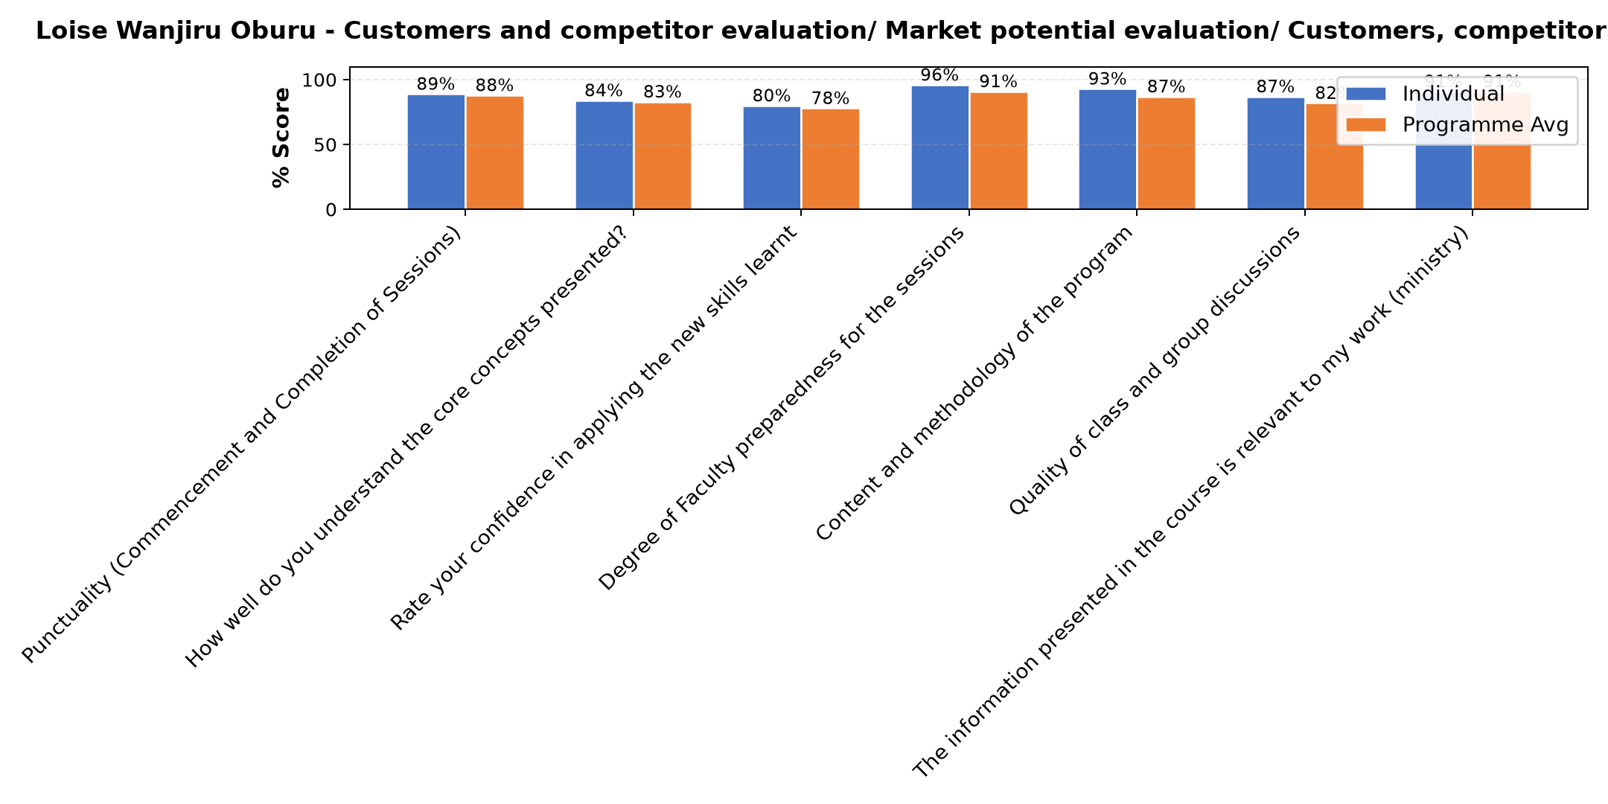

Comments & Feedback
- • No barriers
- • Network problems
- • Fear to apply knowledge
- • Not being close to the project
- • In case am not part or the leader of the enterprise since at times those leading it my take advises for granted.
- • I appreciate the faculty. All I have learned will help me at a personal level, but the ministry level, most of the time our hands are tied. We're now well equipped with entrepreneurship knowledge, but not our Spurious who are the decision makers. Most of the time our ideas are rubished. My suggestion is, our Superiors need this knowledge otherwise, we may not move anywhere
- • The major barrier that might bar application of the content learned is lack of capital.
- • The environment
SUBMITTED THROUGH:
SBS Evaluation Automation System

